Англійська мова Вчитель: Фурт С.В.

Дата: 02.06.2022 6-А клас

Тема: **Повторення за ІІ семестр.**

Мета: узагальнити та систематизувати знання, уміння та навички з тем «Країни та їх столиці», «Лондон»; повторити правила вживання означеного та неозначеного артиклів, Present Simple,Past Simple та Present Perfect; розвивати навички читання; вживання граматичних структур в усному та писемному мовленні; сприяти формуванню комунікативної компетенції.

**Хід уроку**

1. **Introduction. Greeting.**

Good morning dear pupils! How are you today? Are you ready for the lesson? Great! I’m very glad to greet you at our today’s lesson and I hope it will be interesting and useful for you.

**2. Speaking***.* Ex.10 p. 185 Дайте відповіді на питання.

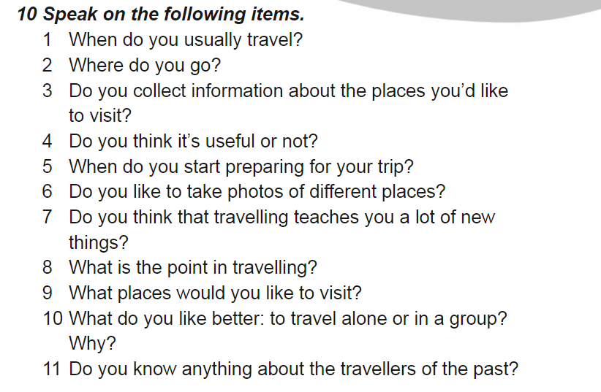

3. **Grammar**. Повторити граматичні часи. Розкрийте дужки та оберіть правильний варіант (усно). Open the brackets and put the correct tense form of the verb (Future Simple, Present Continuous, Past Simple).

1. Tom ___ (not to eat) breakfast yesterday.
2. won’t eat b. doesn’t eat c. didn’t eat
3. His father __ (not to watch) TV at the moment.
4. am not watching b. aren’t watching c. isn’t watching
5. Where _ she __ (to be) tomorrow?
6. Will she be b. has she been c. is she
7. He __ (not to go) to the south a week ago.
8. didn’t went b. didn’t go c. didn’t goed
9. She __ (to enjoy) listening to his songs last night.
10. enjoyed b. has enjoyed c. enjoyes
11. Tom __ (to travel) around the world next year.
12. travels b. will travel c. has traveled
13. I __ (to be) very busy last summer.
14. was b. were c. been
15. I __ (to go) to bed at ten o’clock tomorrow.
16. went b. go c. will go
17. When _ you __ (to leave) home for school tomorrow?
18. are you leaving b. will you leave c. did you leave
19. Look! The baby __ (to sleep).
20. am sleeping b. is sleeping c. are sleeping
21. __ he __ (to play) now?
22. Did he play b. Is he playing c. Will he sleep
23. __ granny _ (to cook) dinner now?
24. Is granny cooking b. Did granny cook c. Will granny cook

**4. Reading**

*The Houses of Parliament*

Its official name is the Palace of Westminster. Most of the building was built in 1840 after a fire in 1834 destroyed the old palace. At the north end of the building by Westminster Bridge is the famous clock tower, Big Ben.

*The National History Museum*

Situated in Kensington. One of London’s greatest museums. A huge collection of animals and plants, including a quarter of a million butterflies, a blue whale and the famous dinosaur skeletons. Cafeteria, gift shop and book shop. Open daily 10 — 5.45.

*Madame Tussaud's Museum*

This famous waxworks has models of famous people from pop stars to prime ministers. Displays of battles and Chamber of Horrors. Gift shop.

Open every day 10 — 5.30, except Christmas Day.

**5*.* Writing.** Open the brackets and form Present Perfect. **Розкрийте дужки та поставте дієслово у Present Perfect:**

1. We _____ (already to learn) a lot of English words.
2. The boy __ ( not to do) his homework yet.
3. He __ (already to learn) the rule.
4. I __ (not to eat) yet.
5. I __ (not to see) him since 1987.
6. You __ (to book) tickets? – Yes, I __

**6. Homework**

Виконайте останню вправу (Writing) письмово та надішліть у Хьюмен.